Video Workshops #1

Speaker: Mr. Dennis Dupps, Technology Research Coordinator for CEEMS
Date: Thursday, July 14, 2016
Time: 9-11 AM
Venue: University of Cincinnati, Zimmer Hall, room 414

Prepared by:
Samantha Lafin, Scott High School, Taylor Mill, Kentucky
RET Participants for Project #3: “Enhancing Decision Making Emulating Human Reasoning”

This session was given by Mr. Dennis Dupps, Technology Research Coordinator for CEEMS on Thursday, July 14, 2016 from 9-11 AM at the University of Cincinnati in Zimmer Hall, room 414. Before attending the session, Mr. Dupps assigned the participants to start working on what will be their unit videos, completed in the spring. They were instructed to create a basic Power Point, how to create animations in the slides, inserting transitions between the slides, and how to record a voiceover for the presentation.

Dennis Dupps currently serves as the Technology Resource person for the CEEMS grant at UC. He earned BS in Industrial Arts Education at Morehead State University and a Masters in Secondary Education from UC, as well as, additional coursework in Information Technology, Computer Science, Digital Video Productions and Robotics. He has been a high school technology teacher at Indian Hill High School for the past 45 years. He served as the President of the Ohio Technology Education Association from 1984-86. He continues to teach part time at Indian Hill High School and is the faculty advisor of the Indian Hill Television Network which produces a weekly news program and many sports and musical programs throughout the district.
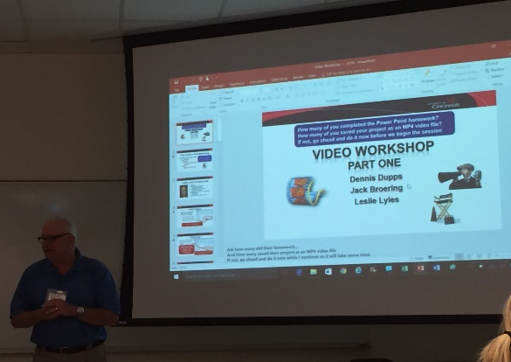
Figure 1: Mr. Dupps Introducing the Session Figure 2: Introducing Leslie Lyles

Mr. Dupps gave a brief introduction to the session by discussing what should have been done to the video already and what we should have to work with, as well as introducing our goals for our session. He then introduced Leslie Lyles, who was in Cohort 4 for CEEMS and had created a video during her CEEMS experience, which was watched by the participants prior to the session. Mr. Dupps then showed Ms. Lyles’s video, “Better than Khan”, which showed her unit where students created math videos comparable to a Khan Academy video. After the video, Ms. Lyles talked to the group about some of her successes and failures with the video assignment.

The next part of the session, Mr. Dupps introduced how to save the files properly and utilize Windows Movie Maker in order to add music and create the video. Mr. Dupps walked through a few slides to introduce the proper procedure and then gave the participants time to work on their videos. Mr. Dupps then worked on editing audio levels so that participants could have music through their whole video, but wouldn’t block out their voice levels, as well as how to cut the music in and out when necessary.

Many participants in the session were struggling with the application of what was being taught, so Mr. Dupps started and stopped the session and walked around to help the participants with the assignment. The video skills he is teaching will be used by the participants throughout the next year, so the application of the session was necessary.

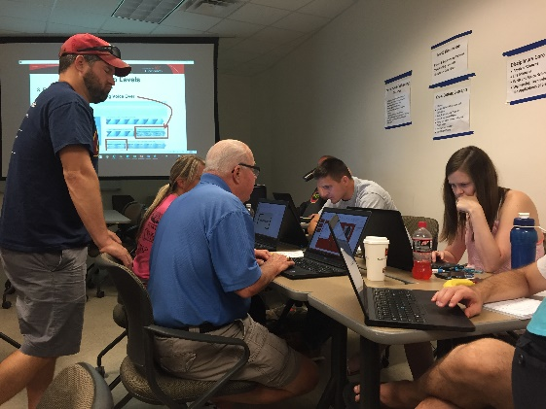
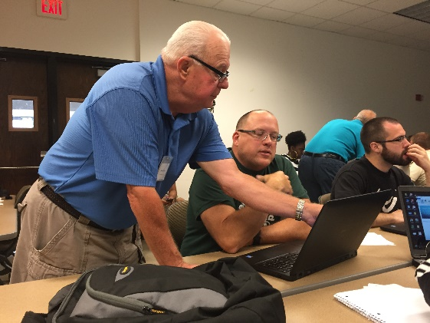

Figures 3 and 4. Mr. Dupps Helping Session Participants

After spending a significant amount of time helping various participants, Mr. Dupps redirected back to the Power Point notes to give some concluding information for the session. He gave explicit details on how to save and some basic troubleshooting tips for session participants.

